Zomato Customer Analysis
Understanding High-Value Customers and Unlocking Untapped Revenue
Final Project Report
Research Area: Customer Analysis Segmentation

1. Introduction
This report presents the findings, conclusions, and recommendations from a customer analysis of Zomato, a multinational restaurant aggregator and food delivery platform operating primarily in India. The analysis was conducted as part of a Business Intelligence onboarding assignment, focusing on Customer Analysis Segmentation.
The main objective was to answer three connected research questions: who are Zomato's most valuable customers, who are the registered users Zomato is failing to convert into buyers, and what does the overall customer base look like. The analysis draws on two datasets — a users table (100,000 registered customers) and an orders table (150,281 orders) — spanning October 2017 to June 2020.
Because Zomato's primary revenue stream is commission charged to restaurants per completed order, every additional order directly generates revenue. This means understanding which customers order frequently, which customers have been lost, and which customers have never ordered are all questions with direct financial implications for the business.

2. Data Preparation and Methodology

2.1 Data Sources
Two of the five available tables were used as the primary data sources for this analysis. The users table contained 100,000 rows with demographic attributes including Age, Gender, Marital Status, Occupation, Monthly Income, Educational Qualifications, and Family Size. The orders table contained 150,281 rows with order_date, sales_qty, sales_amount, currency, user_id, and r_id.

2.2 Data Cleaning
The following cleaning decisions were made prior to analysis, each documented with explicit reasoning.
- Negative sales_amount values (-1, 2 occurrences): Both rows shared an identical sales_qty (3) and order_date (2018-05-08). Comparing against other orders confirmed that -1 has no plausible business interpretation. Decision: deleted as data errors.
- USD currency rows (2 occurrences): Two orders were denominated in USD rather than INR. Converting would require an arbitrary historical exchange rate. Decision: deleted as likely data entry errors.
- Zero-value orders (1,609 occurrences): Spread across 488 distinct dates with no clustering by date or user, suggesting legitimate free or promotional orders rather than a system error. Decision: retained for frequency counts (since the customer did place an order) but excluded from spend calculations. A column called exclude_from_monetary was added to the orders table using an IF formula — orders with a sales_amount of zero were marked 'Yes' and all other orders marked 'No.' When calculating each customer's total spend, only orders marked 'No' were included, preventing zero-value orders from artificially lowering average spend figures.
- Maximum sales_qty (14,049): Implied price per item of approximately 44.75 INR is consistent with normal food pricing. Decision: retained as a legitimate bulk or corporate order.
- Maximum sales_amount (1,510,944 INR): Implied price per item of approximately 2,084 INR. Could not be fully confirmed as legitimate or erroneous. Decision: retained with a documented caveat.
- All monetary values retained in INR. Currency conversion was considered and rejected — it would require an arbitrary exchange rate choice and would not change any relative comparisons between customers.

2.3 Customer-Level Dataset Construction
A customer_base table was built using the users table as the foundation. All 100,000 registered users, one row per customer, with order metrics calculated via lookup formulas referencing the cleaned orders table. This approach preserved all users including those with no order history, enabling direct comparison between active and non-ordering populations. The following columns were calculated per customer:
- order_count: total number of orders placed
- total_spend: sum of sales_amount excluding zero-value orders
- last_order_date: most recent order date
- recency_days: days between last order date and the dataset reference date of June 26, 2020
- customer_status: Active (order_count > 0) or Non-Ordering (order_count = 0)

2.4 RM Scoring Methodology
A modified RM (Recency + Monetary) scoring model was implemented. Frequency was excluded from formal scoring for two reasons: range compression (order counts ranged only from 1 to 9 with an average of 1.93, producing quintile breakpoints too close to be meaningfully distinct) and tenure blindness (raw order count does not distinguish a customer who placed 2 orders in their first week from one who placed 2 orders over two years).
Scores were assigned using predefined quintile cutpoints calculated directly from the 77,929 active customers. Each metric was divided into five equal groups of approximately 15,585 customers, and the values at the 20%, 40%, 60%, and 80% positions became the scoring boundaries.
Score | Recency (days since last order) | Monetary (total spend INR) | Interpretation
5 | 0-141 days | 12,441+ INR | Best
4 | 142-298 days | 3,588-12,440 INR | Good
3 | 299-471 days | 1,043-3,587 INR | Average
2 | 472-688 days | 316-1,042 INR | Below average
1 | 689+ days | 0-315 INR | Lowest

Recency and Monetary are scored independently on the same 1-5 scale using the cutpoints above. The two scores are then added together to produce a combined RM score ranging from 2 (lowest possible) to 10 (highest possible).

3. Findings
The findings are presented across a three-page Power BI dashboard covering revenue and activity overview, customer segmentation, and customer portrait respectively.

3.1 Customer Base Overview
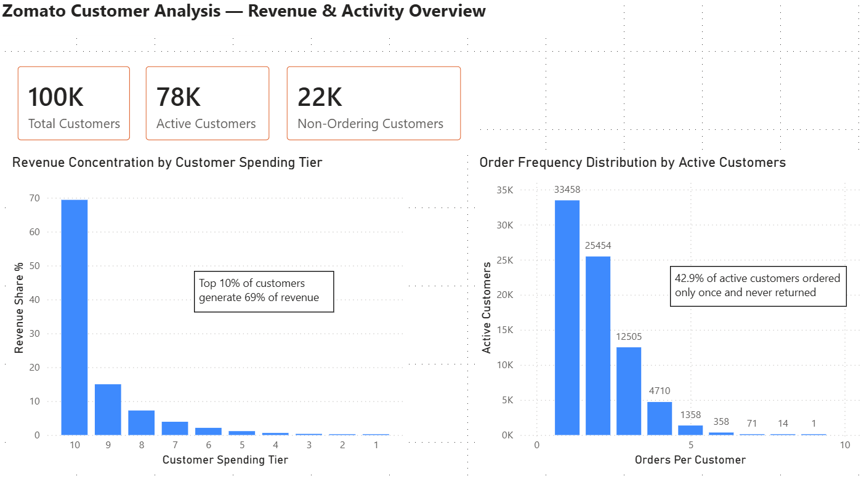Of the 100,000 registered Zomato users in this dataset, 77,929 (77.9%) have placed at least one order. The remaining 22,071 (22.1%) have never placed an order despite being registered on the platform.
The registered customer base is demographically narrow and homogeneous. The average age is 24.6 years, with all users falling between 18 and 33. The base is predominantly students (53%), with employees comprising 30% and self-employed users 14%. Nearly half (48%) report no income. Gender is close to balanced at 53% male and 47% female. These characteristics are consistent across the entire base regardless of ordering behavior.

3.2 Revenue Concentration
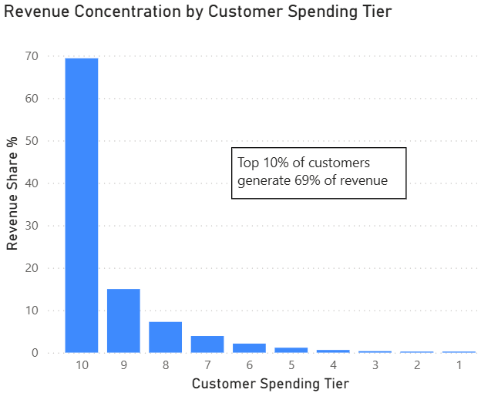
Revenue is highly concentrated among a small group of customers. The top 10% of customers by total spend generate 69.3% of all revenue. The top 20% account for 84.3% of total revenue. The bottom 50% of customers generate only 2.4% of total revenue combined.
This extreme concentration means that losing even a fraction of the highest-spending customers would have a disproportionate impact on Zomato's commission revenue. Conversely, modest improvements in retention among this group would deliver outsized financial returns.

3.3 Order Frequency and Retention
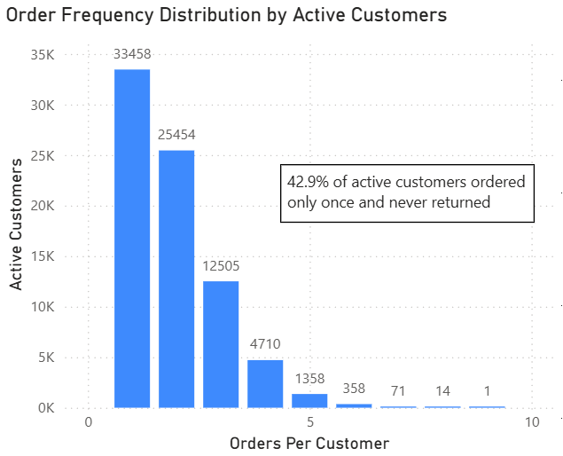
Order frequency among active customers is critically low. The maximum number of orders placed by any single customer is 9, and the average is 1.93. The distribution is steeply right-skewed:
- 33,458 customers (42.9% of active customers) placed exactly one order and never returned
- 25,454 customers (32.7%) placed exactly two orders
- 12,505 customers (16.1%) placed three orders
- Fewer than 2% of active customers placed 5 or more orders

Importantly, average spend per order is remarkably consistent across frequency tiers. Customers who ordered once spent approximately the same per order as customers who ordered five or more times. This means high-value customers are high-value purely because they came back repeatedly, not because they spent more per visit.

3.4 RM Score Distribution and High-Value Segment
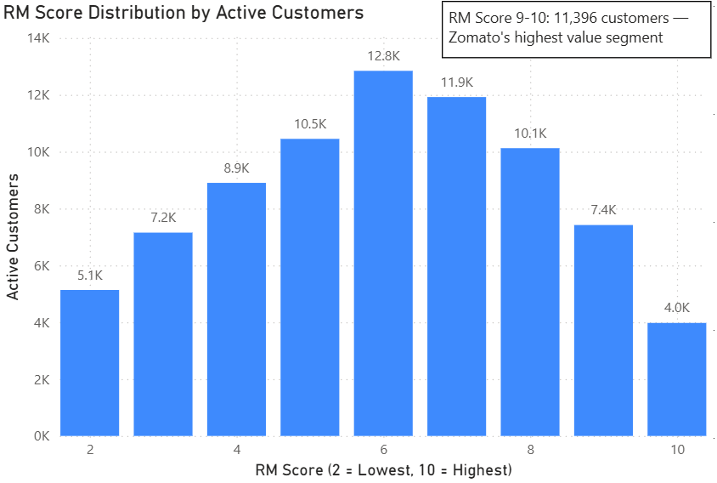
The RM score distribution across 77,929 active customers follows a natural bell curve peaking at score 6, which is mathematically expected when adding two independent 1-5 scores. Within this distribution, 11,396 customers score 9 or 10, the highest possible combined score for both Recency and Monetary dimensions. These customers are both recent and high-spending, representing Zomato's most engaged and most valuable active segment.

3.5 Lapsed Repeat Customers
A particularly important sub-segment was identified within the active customer base: customers who placed more than one order (demonstrating willingness to return to the platform) but have not ordered in more than 471 days (placing them in the bottom 40% of recency). This segment comprises 11,675 customers or 15% of all active customers.
Their average historical spend of 15,512 INR is 23% above the overall active customer average of 12,660 INR. This is not a coincidence, customers who ordered more than once had inherently higher engagement and higher spending. The fact that they have gone quiet for an average of over 21 months may suggest lapsing rather than dissatisfaction, though this cannot be confirmed from order data alone. Either way, their proven order history makes them a strong candidate for re-engagement.

3.6 Demographics Are Flat Across All Segments
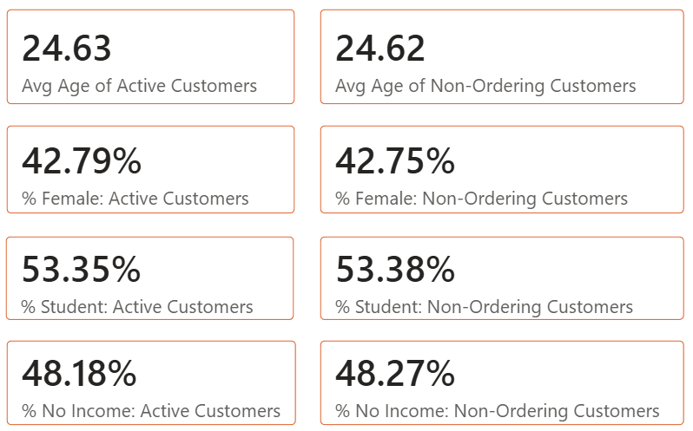A critical finding emerged when comparing the demographic profiles of active customers versus non-ordering customers across every available dimension:
Demographic | Active Customers | Non-Ordering Customers
Average Age | 24.63 years | 24.62 years
% Female | 42.79% | 42.75%
% Student | 53.35% | 53.38%
% No Income | 48.18% | 48.27%

The same flat pattern holds when comparing high RM score customers (9-10) against low RM score customers (2-3): income, occupation, age, and gender differ by less than 0.5 percentage points across every dimension tested. Hypotheses 1 and 2 from the research plan, that higher-income customers would spend more and that non-ordering users would skew younger and lower income, are not supported by this data.
This is itself a significant finding. It means that demographic attributes captured at registration carry no predictive power for customer value or ordering behavior in this dataset.

4. Conclusions

4.1 Revenue Depends on a Very Small Customer Group
With the top 20% of customers generating 84% of revenue, Zomato's business is highly exposed to the behavior of a small loyal segment. This concentration is not inherently a problem but it means the cost of losing high-value customers is disproportionately high. Protecting this group must be a top business priority.

4.2 The First-to-Second Order Conversion Is the Critical Retention Moment
42.9% of active customers ordered exactly once and never returned. Since average spend per order is consistent across frequency tiers, the economic case is straightforward: a customer who orders twice generates roughly double the lifetime revenue of a one-time customer, at zero additional acquisition cost. Converting one-time buyers to repeat buyers appears to be the highest-leverage intervention available to Zomato in this dataset.

4.3 Lapsed Repeat Customers Are the Highest-ROI Win-Back Opportunity
The 11,675 lapsed repeat customers represent a uniquely valuable segment. They have already demonstrated: willingness to use the platform (they ordered more than once), above-average spending behavior (23% above the active customer average), and sufficient historical engagement to suggest lapsing rather than permanent departure. The combination of proven value and reasonable win-back probability makes this group the most actionable segment identified in this analysis.

4.4 Demographic Targeting Will Not Solve Zomato's Customer Challenges
The flat demographic finding has a direct and important business implication: no demographic group is meaningfully more or less likely to order, and no demographic group is meaningfully more or less valuable when they do order. A newly registered user's age, income, gender, and occupation tell Zomato almost nothing about whether they will become a customer and how valuable they will be.
This rules out demographic segmentation as a marketing strategy for this platform at this stage of its development. It does not mean demographics are permanently irrelevant, but with the data currently available, behavioral signals are far more informative than demographic attributes.

4.5 Non-Ordering Users Require Behavioral and UX-Based Approaches
The 22,071 registered non-ordering users are demographically indistinguishable from active customers. This means Zomato cannot identify them in advance using registration data and target them with demographic messaging. The barrier to their first order is almost certainly not demographic, it is behavioral, experiential, or awareness-based. Possible barriers include friction in the ordering process, uncertainty about the platform, lack of a compelling first-order incentive, or simply not thinking to use the app.

5. Recommendations
Based on the findings and conclusions above, four distinct business strategies are recommended, each targeting a different customer segment with a different behavioral objective.

Strategy 1: Protect High-Value Active Customers (RM Score 9-10)
The 11,396 customers scoring 9 or 10 on the combined RM scale are Zomato's most valuable and most engaged active customers. They are recent, high-spending, and currently loyal. The business priority here is retention. Not acquisition or conversion, but making sure these customers do not drift into the lapsed category.
- Implement a loyalty rewards program or VIP tier for top RM score customers with exclusive benefits such as free delivery, priority support, or early access to promotions
- Set up automated alerts when a top-tier customer's recency begins to increase, an early warning system that triggers re-engagement before they fully lapse into disengagement
- Personalize the app experience for this segment where possible, for example make sure their ordering history is rich enough to support meaningful recommendations

Strategy 2: Win Back Lapsed Repeat Customers
The 11,675 customers who ordered more than once but have been inactive for over 15 months on average represent the most financially compelling win-back opportunity in this dataset. Their above-average historical spend and proven willingness to return for a second order make them worth a targeted re-engagement investment.
- Run a targeted win-back campaign offering a returning customer incentive such as a discount, free delivery, or bonus credit specifically for customers who meet the lapsed repeat criteria
- Having more personalized messaging around their specific order history may be more effective than generic blanket promotions.
- Test a time-based trigger: customers who have not ordered in 6 months receive an initial nudge; customers inactive for 12 months receive a stronger incentive

Strategy 3: Convert One-Time Buyers to Repeat Buyers
With 42.9% of active customers ordering exactly once and never returning, the first-to-second order conversion problem is the largest single behavioral gap in the data. It is a reasonable assumption that customers who return for a second order are more likely to become habitual users than those who ordered once and never returned. The second order is the critical loyalty inflection point.
- Implement a post-first-order follow-up: send a targeted promotion 3-5 days after a customer's first order, offering a discount or free delivery on their second order
- The timing of the follow-up should be deliberately chosen, early enough that the platform is still top of mind, but allowing enough time for the first experience to be memorable. The specific timing window should be determined through testing.
- Track first-to-second order conversion rate as a primary business KPI, it is currently invisible in standard reporting but is arguably the most important metric for long-term revenue growth

Strategy 4: Activate Non-Ordering Registered Users
The 22,071 registered users who have never ordered cannot be reached through demographic targeting since they are statistically identical to active customers. Interventions must therefore be behavioral and UX-focused rather than audience-based.
- Offer a first-order incentive, a discount, free delivery, or cashback, triggered for users who have been registered for more than 7 days without placing an order
- Audit the ordering flow for friction points that may be preventing conversion: payment method limitations, unclear delivery estimates, or confusing UI elements
- Consider an awareness campaign targeting all registered users broadly, since demographic sub-targeting offers no advantage in this dataset
- Note that registration timing data was not available in this dataset, so it is not possible to determine how recently these users registered. Some may be recent registrants who simply have not yet had time to order. A future analysis with registration dates would allow more precise targeting of genuinely inactive vs. recently registered non-orderers

6. Limitations and Areas for Further Analysis
- Frequency excluded from formal RM scoring due to range compression (1-9 orders) and tenure blindness. A future analysis with longer data history and wider frequency ranges would support more robust RFM scoring.
- Registration date not available in the users table, preventing analysis of registration timing patterns for non-ordering users.
- Income brackets are broad, limiting the precision of income-based analysis. The top bracket (More than 50,000 INR/month) captures a very wide range of actual incomes.
- The maximum sales_amount outlier (1,510,944 INR) could not be fully confirmed as legitimate or erroneous from the data alone and was retained with a caveat.
- The data covers October 2017 to June 2020 only. Customer behavior and platform usage may have changed significantly since then.
- No behavioral data beyond orders is available — no app browsing data, search history, or session data — which limits the depth of behavioral analysis possible with this dataset.

7. Summary
This analysis revealed that Zomato's customer revenue is extremely concentrated, its retention rates are low, and its demographic data does not predict customer value or behavior. The four recommendations: protect top customers, win back lapsed repeat customers, convert one-time buyers, and activate non-ordering users, address four distinct segments with four distinct behavioral strategies. Taken together they represent a shift from demographic targeting toward behavioral intervention, which the data strongly supports as the more effective approach for this platform and customer base.

